December 22, 2024
OCHEYEDAN CHRISTIAN REFORMED CHURCH
833 5th Street, Ocheyedan, Iowa 51354
Morning Worship Service – 9:30 AM
Live on Facebook- Ocheyedan CRC
Pastor Lee Khang

Song of Advent: “O Co me All You Unfaithful”
(Words & Music by: Lisa Clow & Bob Kauflin. Sovereign Grace Praise. 2020.)
Advent Reading
*Call to Worship
*God’s Greeting
*Opening Songs: “Once in Royal David’s City” (LUYH 87:1,2,4)
“Love Has Come!” (Celebration Hymnal 256:1,3)

Blessing of the Children: “The Magi Show the Way to Bethlehem
& Meeting the Christ Child”
Offering: World Renew
Song: “Silent Night! Holy Night!” (LUYH 85:1,3)
Congregational Prayer
*Song of Preparation: “Hark, the Glad Sound! The Savior Comes”
(LUYH 60:1,3)
Scripture: Psalm 36 (page 871)
Message: “An Advent in the Psalms: LOVE”
Prayer of Application
*Song of Application: “Of the Father’s Love Begotten”
(LUYH 78:1,3,4)
*Advent Statement of Faith: Romans 5:6-8
*Parting Blessing
*Parting Song:“Infant Holy, Infant Lowly”
(Celebration Hymnal 279)
Postlude
*Invites those who are able to stand

Evening Worship Service 6:00 PM

Youth Candlelight Service

The Light of the World

A candlelight service that demonstrates
Light overcoming darkness
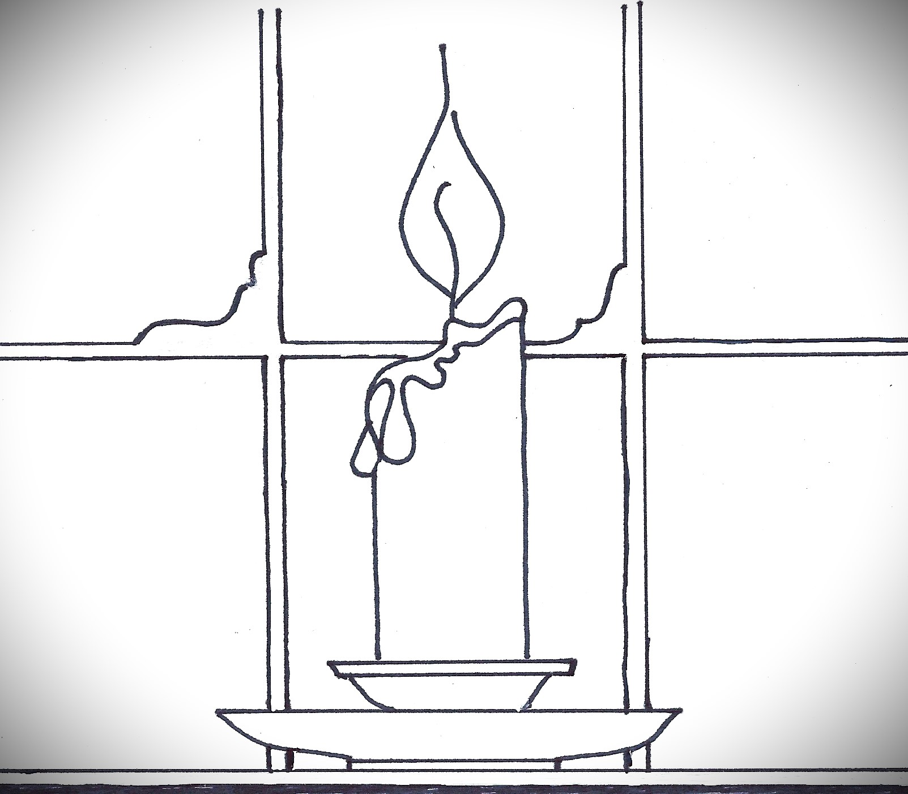
(Please pick up a candle
as you enter for worship)

Prelude and Personal Meditation
Welcome and Announcements
Our Prayer for God's Presence:
“Hark, the Glad Sound! The Savior Comes”
(LUYH 60:1,2,3,4)
God's Greeting
Our Response: "O Come, O Come Emmanuel" (LUYH 61:1,2,3,4)
A Dark World
Our Prayer of Desperation: “O Shepherd, Hear and Lead Your Flock”
(LUYH 64:1,2,3)
A Tiny Flame
Our Songs of Joy: "Angels from the Realms of Glory"
(LUYH 81:1,2,3)
“O Come, All Ye Faithful” (LUYH 76:1,2,3)
A Warming Light
Prayer for Illumination
Scripture Reading: John 8:12
Message: “The Light of the World”
Our Celebration: "Hark! The Herald Angels Sing" (LUYH 80:1,2,3)
A Spreading Glow
(Prayers for God's Light to Grow in the World Through Us)
Hymn of Growing Light: "As with Gladness Men of Old"
(LUYH 105:1,2,3)
Offering: World Renew
Call to Spread the Glow: “Go Light Your Candle"
(As the Youth Sunday School class begins singing,
the light of the Christ Candle is passed to our candles
in a spreading radiance. Until all our candles are lit.)
God's Blessing
A Moment of Silent Meditation

